PROJECT REPORT ON
“CULTURAL EXCHANGE HUB”


Submitted in partial fulfilment of the requirement for the award of the degree of Master of Computer Application
SESSION – 2024-25

Under the Supervision of - Submitted By: -
Mr. Gaurav Choudary Kajol Kumari
Assistant Professor MCA-I (C)
USCS 28

ACKNOWLEDGEMENT
The most awaited moment of any endeavour is successful completion, but nothing can be done successfully if done alone. Success is the outcome of contribution and consistent help of various persons and we thank those ones who helped us in successful completion of this project.
Primarily I would like to thank Prof. (Dr.) Sonal Sharma, Dean USCS for providing a healthy and encouraging environment to study.
I profusely thankful to the Head of Department, USCS, Dr. Sameer Sharma, and my Project Mentor Mr. Gaurav Choudhary, Assistant Professor. He has been generous enough to provide me an opportunity and accepting my candidature for the most valuable guidance and affordable treatment given to us at every stage to boost my morale.

Kajol Kumari
MCA – I (C)

I
DECLARATION
I hereby declare that the project report entitled “Cultural Exchange Hub” submitted by Rohani Kumari to Uttaranchal School of Computing Sciences. The project was done under the guidance of Mr. Gaurav Choudhary. I further declare that the work reported in this project has not been submitted and will not be submitted, either in part or in full, for the award of any other degree or diploma in this university or any other university or institute.

Kajol Kumari
MCA – I (C)

II
CERTIFICATE OF ORIGINALITY
This is to certify that Kajol Kumari student of MCA 1st Semester, of Uttaranchal School of Computing Sciences, Dehradun, has completed the Project Cultural Exchange Hub in Java for the Batch (2024-2026).
Under the Guidance of
Mr. Gaurav Choudhary
Uttaranchal School of Computing
Science, Uttaranchal University

III
INDEX
ACKNOWLEDGEMENT I
DECLARATION II
CERTIFICATE OF ORIGINALITY III
- INTRODUCTION 1
- OBJECTIVE 2
- SYSTEM ANALYSIS 3
  - Feasibility Study 3-4
- PROJECT PLANNING AND SCHEDULING
  - Gantt Chart 5
  - Pert Chart 6
  - Software Requirement Specification 6-7
  - Tools/Platform Used 8
  - Flow Chart 9
  - E-R Diagram 10
  - Use Case Diagram 11-12
  - DFD
    - Level 0 13
    - Level 1 14-15
- SYSTEM DESIGN 16-18
- TESTING 19-24
- REPORTS TO BE GENERATED 25
- SYSTEM SECURITY MEASURES 26
- FUTURE SCOPE OF THE PROJECT 27
- APPENDICES
  - Coding 28-49
  - Bibliography 50
LIST OF FIGURES
S.no | Fig.no | Topics | Page.no
1. | Fig.No.1 | Gantt chart | 5
2. | Fig.No.2 | Pert Chart | 6
3. | Fig.No.3 | Flow Chart | 9
4. | Fig.No.4 | ER Diagram | 10
5. | Fig.No.5 | Use-Case Diagram | 11-12
6. | Fig. No.6 | DFD | 13-15

- INTRODUCTION
A cultural exchange hub serves as a vibrant centre where individuals from diverse backgrounds come together to share and celebrate their unique traditions, languages, and customs. These hubs often host various events, such as festivals, workshops, and exhibitions, which provide opportunities for participants to learn about different cultures in an interactive and immersive environment. By offering language classes, cooking demonstrations, and traditional arts and crafts sessions, cultural exchange hubs foster a deeper understanding and appreciation of global diversity, promoting inclusivity and mutual respect among community members. The exchange of cultural knowledge and practices enriches participants' lives, broadening their horizons and enhancing their intercultural competence.
In addition to fostering interpersonal connections, cultural exchange hubs also play a crucial role in preserving and promoting cultural heritage. By documenting and showcasing traditional practices, these hubs ensure that valuable cultural knowledge is passed down to future generations. They often collaborate with cultural institutions, educational establishments, and local governments to support cultural preservation initiatives and promote cultural diversity as a valuable societal asset. Through their activities, cultural exchange hubs not only celebrate cultural differences but also highlight the commonalities that bind humanity together, inspiring a sense of global citizenship and shared responsibility for a more inclusive and harmonious world.

(1)
- OBJECTIVE
- The Cultural Exchange Hub aims to facilitate cultural sharing by creating numerous opportunities for individuals to showcase their cultural practices, traditions, and values through engaging workshops, webinars, and interactive sessions.
- It is to ensure the longevity of cultural heritage through digital archiving. By developing an extensive digital archive of cultural artifacts, languages, stories, and traditions, the hub will preserve these invaluable elements for future generations.
- Ensuring that cultural resources are accessible to a broad audience, the hub will support a multilingual platform.
- By hosting virtual and physical art and culture exhibitions, the hub will showcase artistic and cultural expressions from around the world.
- The hub plans to develop educational programs that can be seamlessly integrated into school curriculums, enriching students' understanding of global cultures.

(2)
- SYSTEM ANALYSIS
System analysis is a crucial phase in the development lifecycle of any system, whether it's software, a business process, or an infrastructure project.
PROBLEM IDENTIFICATION
There is a significant gap in the current digital landscape for a dedicated platform that facilitates meaningful cultural exchanges. Individuals, educators, and cultural organizations lack a centralized space where they can connect, share cultural experiences, and learn from diverse global perspectives. Existing platforms are either too broad, lacking specific cultural exchange features, or too fragmented, making it difficult to build sustained, enriching interactions. A Cultural Exchange Hub would address this gap by providing a specialized, user-friendly platform tailored to fostering global cultural understanding and connections.
PROPOSED SOLUTION
The Cultural Exchange Hub will be an online platform connecting individuals, educators, and cultural organizations to share and learn from diverse cultural experiences. It will feature user profiles, multimedia content sharing, messaging, forums, virtual event management, advanced search functions, and educational resources. Designed for accessibility and inclusivity, the platform will promote global cultural understanding and connections.
  - FEASIBILITY STUDY
    - Technical Feasibility
It involves using a modern technology stack, including frontend frameworks like React for a dynamic user interface and backend solutions such as Node.js for server-side operations. A scalable database like MySQL will securely store user profiles and content. Overall, the proposed technologies and architecture will support a scalable, secure, and user-friendly platform.
    - Economical Feasibility
The economic feasibility of the Cultural Exchange Hub evaluates the project’s costs against
(3)
potential revenue streams to determine its viability. Initial development costs will include expenses for technology stack implementation, hosting services, design, and ongoing maintenance. Funding may be sourced from grants, partnerships with cultural organizations, or crowdfunding. Revenue can be generated through premium memberships, sponsorships, advertising, and event fees.
    - Operational Feasibility
It assesses the platform's ability to function effectively within its intended environment. Key considerations include the required technical skills for development and maintenance, which can be addressed by employing a skilled development team or collaborating with technology partners. User support will be essential, necessitating a dedicated team for assistance, content moderation, and community engagement.

(4)
4. PROJECT PLANNING AND SECHDULING
4.1 GANTT CHART
TASK | START DATE | DURATION | END DATE
Conceptualization and Introduction | Aug 29, 2024 | 10 days | Sep 7, 2024
System Analysis | Sep 8, 2024 | 14 days | Sep 21, 2024
Architectural Design and Implementation | Sep 8, 2024 | 35 days | Oct 12, 2024
Documentation Initiation | Oct 13, 2024 | 30 days | Nov 12, 2024
Testing | Nov 13, 2024 | 10 days | Nov 22,2024
Generation of Report | Nov 23,2024 | 7 days | Nov 29,2024
Finalisation of Report and Documentation | Nov 30,2024 | 2 days | Dec 1,2024

Fig 1: Gantt Chart

(5)
4.2 PERT CHART
START

Requirement Gathering

UI/UX Design
Database Design
Architectural Design

UI Development
API Development
Database Development

Implementation

Integration and Testing

Finish
Fig 2: Pert Chart
(6)
4.3 SOFTWARE REQUIREMENT SPECIFICATION
Introduction
This document is to provide a description of the Cultural Exchange Hub, an online platform aimed at fostering global cultural exchange and learning.
Purpose
Cultural Exchange Hub aims to provide a description about its goals, functional and non-functional requirements, and overall system design. It ensures all stakeholders have a clear understanding of the system's functionalities and constraints.
Scope
The Cultural Exchange Hub will be an online platform designed to connect individuals, educators, and cultural organizations for the purpose of cultural exchange and learning.
Benefits
Cultural Exchange Hub improved Cultural Understanding, Educational Opportunities, Promotion of Global Citizenship, Support for Cultural Organizations.

4.3.1 Functional Requirements
Cultural Exchange Hub include user registration and profile management, multimedia content creation and sharing, comprehensive event management tools, advanced search and discovery features.
4.3.2 Non-Functional Requirements
The system must ensure high performance, user friendly, minimizing latency, security, usability and scalability.

(7)
4.4 TOOLS/PLATFORM USEDS
- MINIMUM SOFTWARE REQUIRED
- Laptops/Desktops RAM: 512 MB
- RAM or above Processor: Intel core2 duo or above
- Processor Speed: 1.0GHZ or above
- Hard Disk: 50GB hard disk or above
- SOFTWARE CONFIGURATION
- Operating System: Microsoft Windows 7 or above
- Client: Node.js, HTML, Bootstrap, CSS
- Database: MySQL
- IDE: Visual studio 2022
- HARDWARE BEING USED
- RAM: 16 GB
- RAM Processor: AMD Ryzen 5 7520U
- Processor Speed: 2.80 GHz
- Hard Disk: 512 GB SSD

(8)
4.5 FLOWCHART
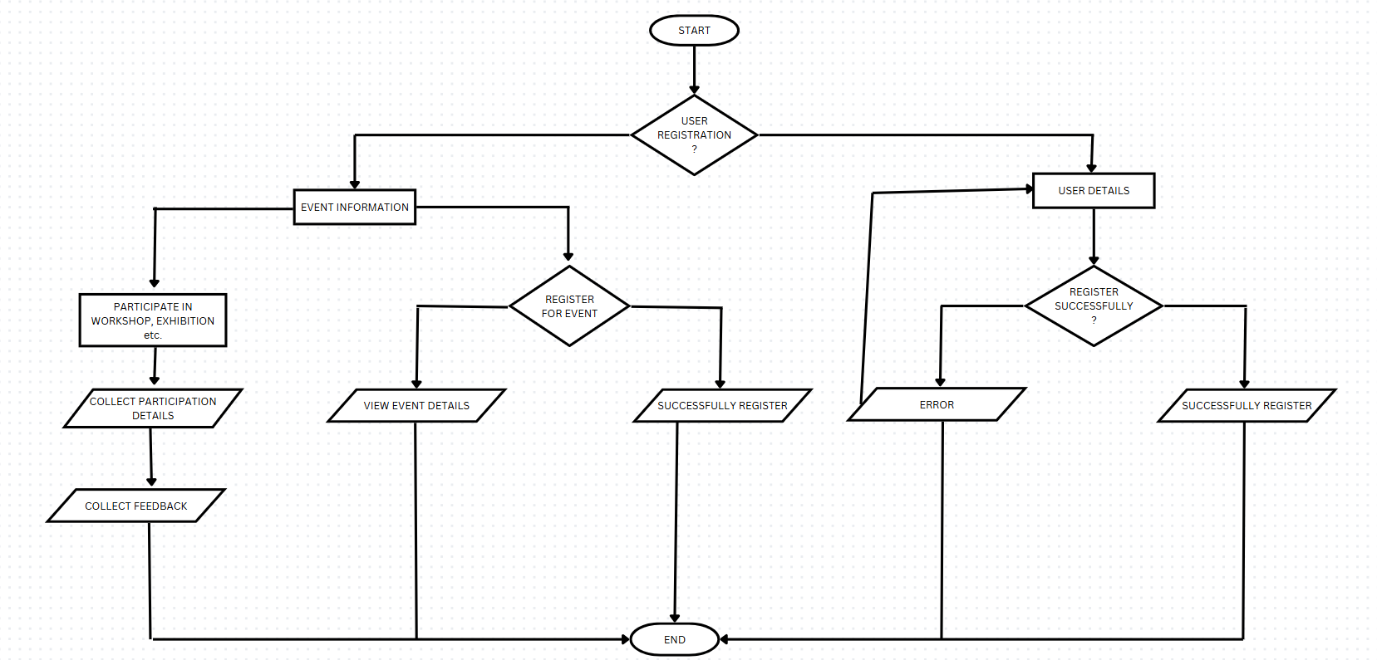
Fig 3: Flowchart
(9)
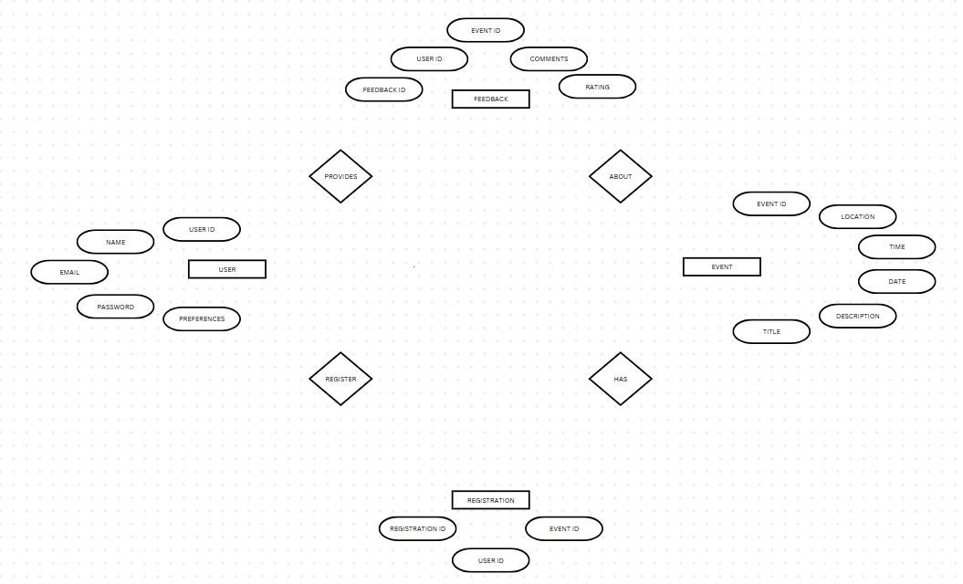
4.6 E-R DIAGRAM
Fig 4: ER Diagram
(10)
4.7 USE-CASE DIAGRAM
REGISTER USER
LOGIN
VIEW EVENTS
(11)
ATTEND COOKING DEMONSTRATION
ENGAGE IN ARTS AND CRAFTS
FOOD EXCHANGE FESTIVAL
MUSIC EXCHANGE
PROVIDE FEEDBACK
ACTOR
USER
CULTURAL DANCE EXCHANGE
JOIN LANGUAGE CLASS
REGISTER FOR EVENT

MANAGE EVENT
PROVIDE FEEDBACK
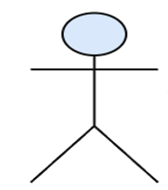
MANAGE USER
VIEW FEEDBACK
ACTOR
ADMIN
ACTOR
ADMIN

BROWSE AS VISITOR

VIEW EVENT
ACTOR
VISITOR

D
ACTOR
VISITOR

Fig 5: USE CASE DIAGRAM

(12)
4.7 DFD

0-LEVEL DATA FLOW DIAGRAM

SIGN UP / LOGIN
USER
(13)
LOGIN
UPLOAD CONTENT
VIEW PREFERRED CONTENT
CULTURAL EXCHANGE HUB
ADMINISTRATOR

Fig 6: DFD
1-LEVEL DATA FLOW DIAGRAM
User Registration:-
VALIDATE

UserID, Email, Password
Yes or No

User Information
USER REGISTR-ATION
User Information to Table
USER
USER INFORMATION

Click on agree all the statement in terms of service.
USER LOGIN

(14)
User Login:

User Account Management
User Registration
Validate Registration Details

Inquiries
User Account Form
Registered User
User Account
Registration Form
User Details
User
Registration Details
System Access
Login Information
Registration

Accounts
Login Details

Login Verification

(15)
5. SYSTEM DESIGN


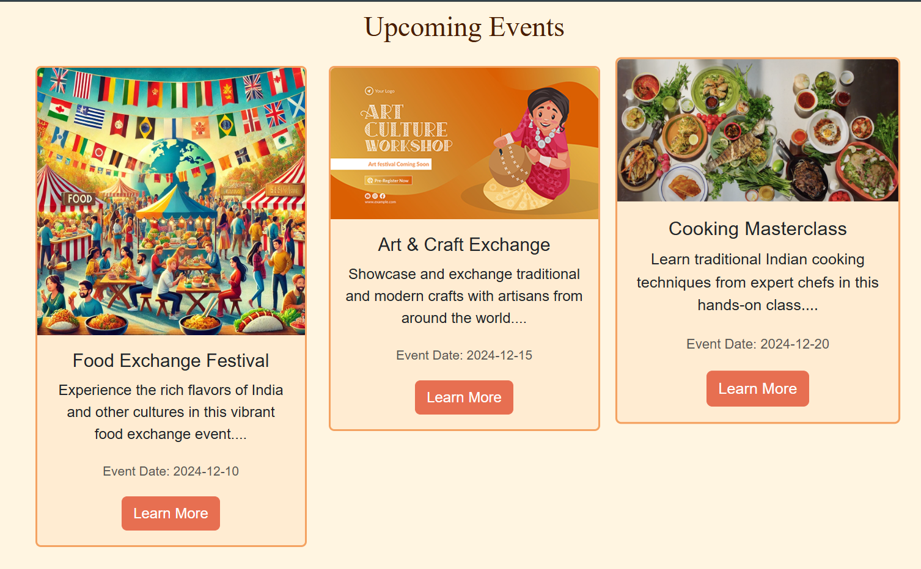

(16)
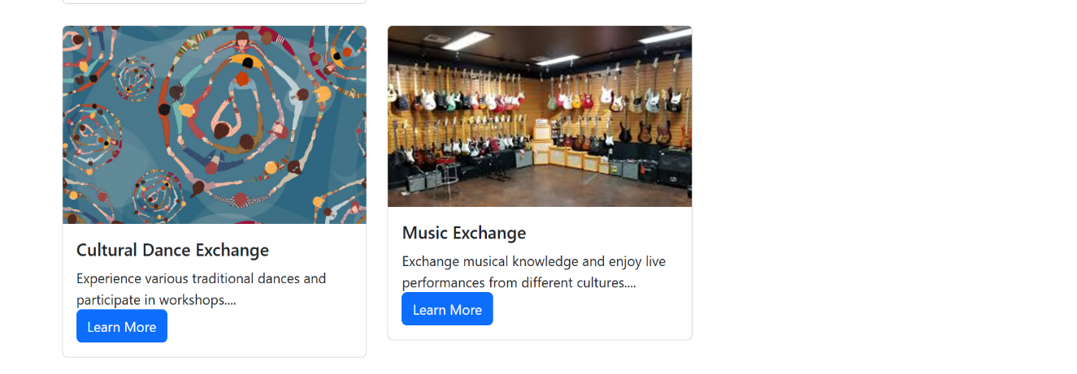
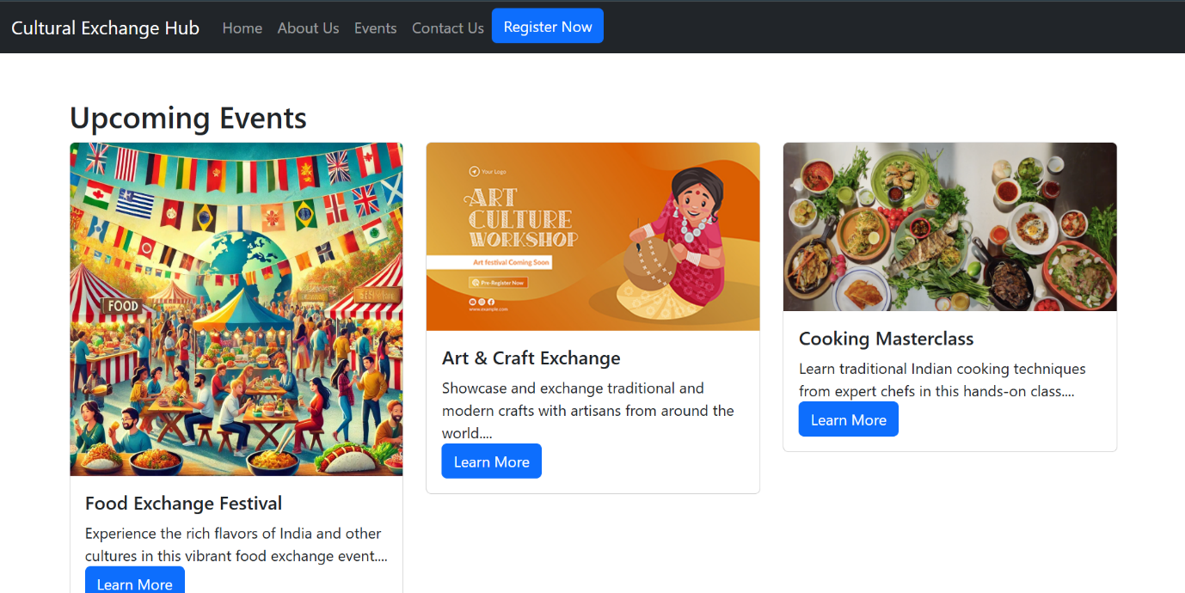
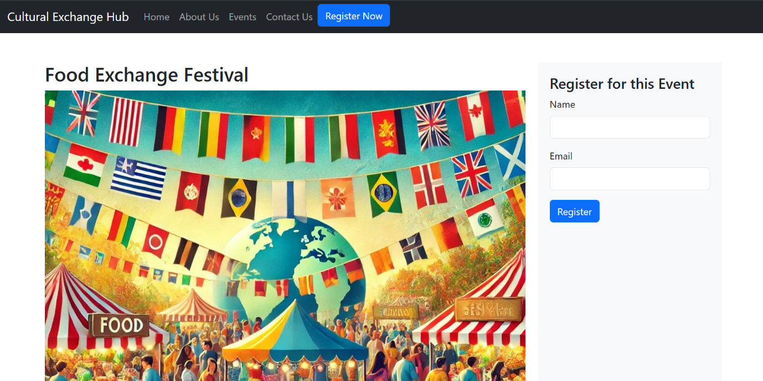
(17)
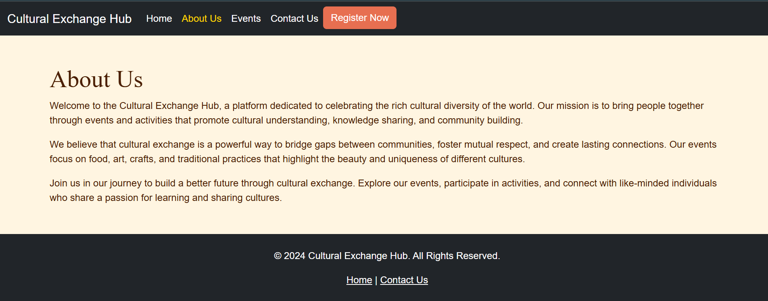

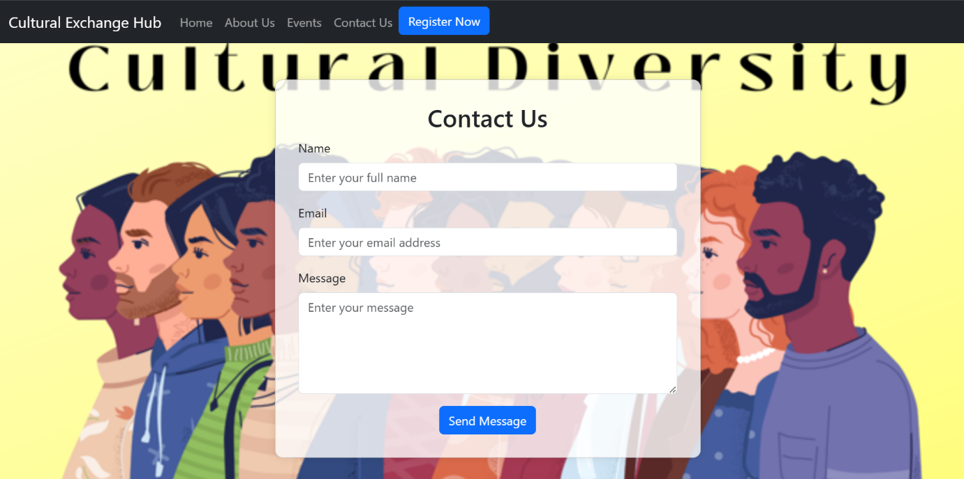

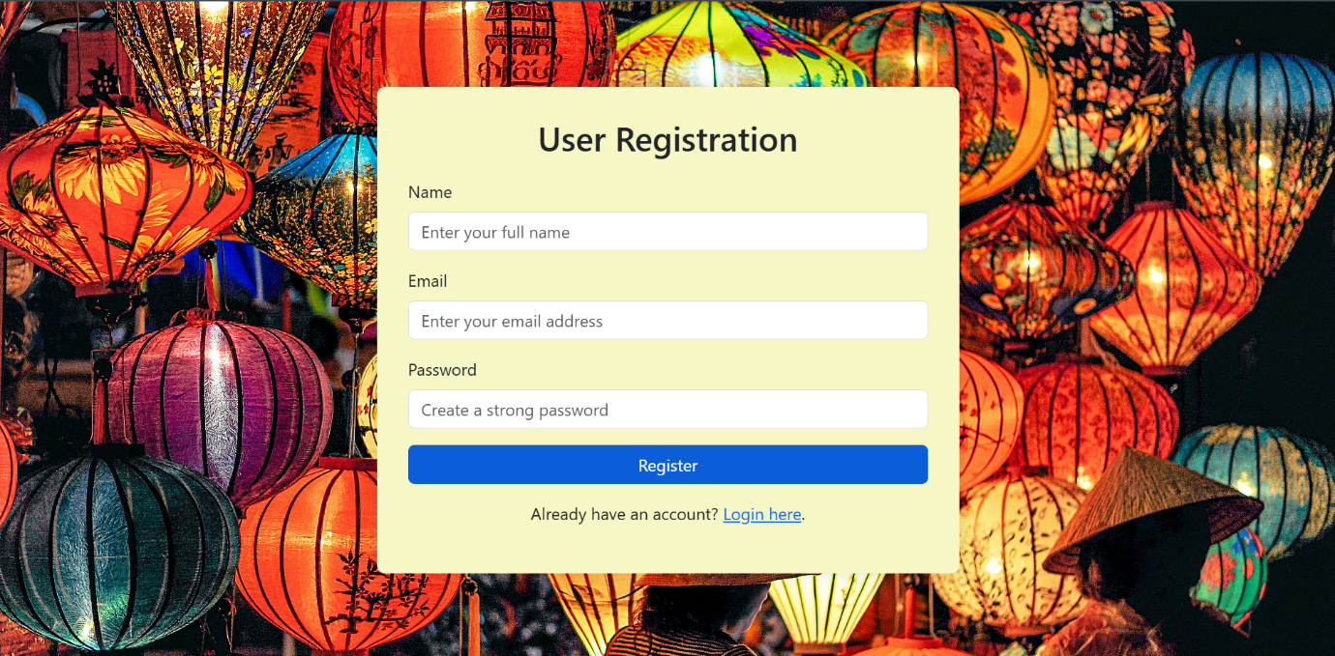

(18)
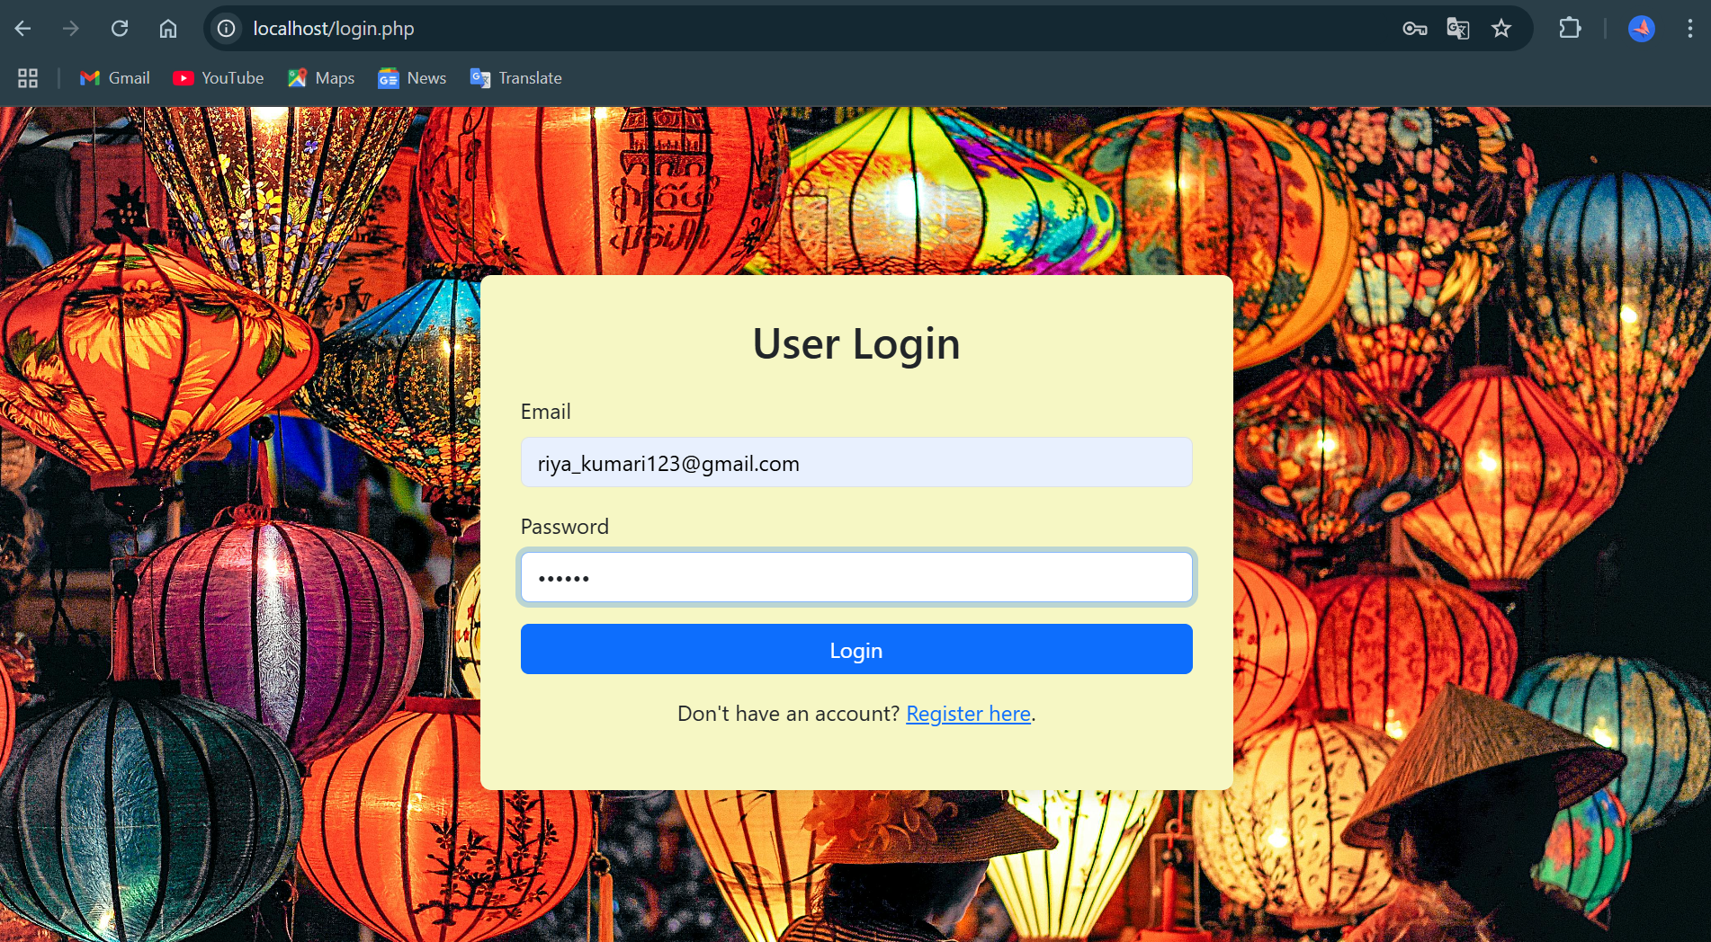
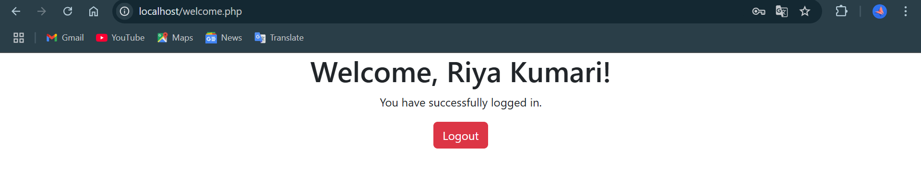

(19)
6.TESTING
6.1 Testing Techniques and Testing Reports
Unit Testing:
Unit tests are automated and are run each time the code is changed to ensure that new code does not break existing functionality. Unit tests are designed to validate the smallest possible unit of code, such as a function or a method, and test it in isolation from the rest of the system.
Objectives:
- To verify the correctness of the code.
- To test every function and procedure.
- To fix bugs early in the development cycle and to save costs.
- To help the developers understand the code base and enable them to make changes quickly.
- To help with code reuse.
Test Case:

Test Case 1: User Registration
- Test Case ID: 01
- Description: Verify that a new user can register successfully.
- Precondition: None
- Test Steps:
- Navigate to the registration page.
- Enter valid details (name, email, password).
- Click the "Register" button.
- Result: User is successfully registered and redirected to the login page.
Test Case 2: User Login
(20)
- Test Case ID: 02
- Description: Verify that a registered user can log in successfully.
- Preconditions: User must be registered.
- Test Steps:
- Navigate to the login page.
- Enter valid credentials (email and password).
- Click the "Login" button.
- Result: User is successfully logged in and redirected to the homepage.
Test Case 3: View Events
- Test Case ID: 03
- Description: Verify that users can view the list of upcoming events.
- Preconditions: User must be logged in.
- Test Steps:
- Navigate to the events page.
- Result: A list of upcoming events is displayed.
Test Case 4: Register for Event
- Test Case ID: 04
- Description: Verify that a user can register for an event.
- Preconditions: User must be logged in and events must be available.
- Test Steps:
- Navigate to the events page.
- Select an event and click "Register".
- Confirm the registration.
- Result: User is successfully registered for the event and receives a confirmation message.
Test Case 5: Provide Feedback
- Test Case ID: 05
- Description: Verify that a user can provide feedback for an event they attended.
- Preconditions: User must be logged in and must have attended an event.

(21)
- Test Steps:
- Navigate to the feedback page.
- Select the event and enter feedback details (comments, rating).
- Click the "Submit Feedback" button.
- Result: Feedback is successfully submitted and stored.
Test Case 6: Manage Events (Administrator)
- Test Case ID: 06
- Description: Verify that an administrator can add a new event.
- Preconditions: Admin must be logged in.
- Test Steps:
- Navigate to the admin dashboard.
- Click on "Add Event".
- Enter event details (title, description, date, time, location).
- Click the "Submit" button.
- Result: New event is successfully added and listed in the events page.
Test Case 7: Manage Users (Administrator)
- Test Case ID: 07
- Description: Verify that an administrator can manage user accounts.
- Preconditions: Admin must be logged in.
- Test Steps:
- Navigate to the admin dashboard.
- Click on "Manage Users".
- Select a user and update details (name, email, preferences) or delete the user.
- Click the "Save" button.
- Result: User details are successfully updated or the user is deleted.
Test Case 8: View Feedback (Administrator)
- Test Case ID: 08
- Description: Verify that an administrator can view feedback from users.
- Preconditions: Admin must be logged in.
(22)
- Test Steps:
- Navigate to the admin dashboard.
- Click on "View Feedback".
- Result: Feedback from users is displayed.
Test Case 9: Participate in Workshop
- Test Case ID: 09
- Description: Verify that a user can participate in a workshop.
- Preconditions: User must be logged in and workshops must be available.
- Test Steps:
- Navigate to the workshops page.
- Select a workshop and click "Participate".
- Confirm participation.
- Result: User is successfully registered for the workshop and receives a confirmation message.
Test Case 10: Join Language Class
- Test Case ID: 10
- Description: Verify that a user can join a language class.
- Preconditions: User must be logged in and language classes must be available.
- Test Steps:
- Navigate to the language classes page.
- Select a class and click "Join".
- Confirm participation.
- Result: User is successfully registered for the language class and receives a confirmation message.
Test Case 11: Attend Cooking Demonstration
- Test Case ID: 11
- Description: Verify that a user can attend a cooking demonstration.
- Preconditions: User must be logged in and cooking demonstrations must be available.
(23)
- Test Steps:
- Navigate to the cooking demonstrations page.
- Select a demonstration and click "Attend".
- Confirm participation.
- Result: User is successfully registered for the cooking demonstration and receives a confirmation message.
Test Case 12: Engage in Arts and Crafts Session
- Test Case ID: 12
- Description: Verify that a user can engage in an arts and crafts session.
- Preconditions: User must be logged in and arts and crafts sessions must be available.
- Test Steps:
- Navigate to the arts and crafts sessions page.
- Select a session and click "Engage".
- Confirm participation.
- Result: User is successfully registered for the arts and crafts session and receives a confirmation message.
Test Case 13: Food Exchange Festival
- Test Case ID: 13
- Description: Verify that a user can join a Food Exchange Festival.
- Preconditions: User must be logged in and Food Exchange Fest must be available.
- Test Steps:
- Navigate to the Food Exchange Festival page.
- Enter the details and click "Register".
- Confirm participation.
- Result: User is successfully registered for the Food Exchange Festival and receives a confirmation message.
Test Case 14: Cultural Dance Exchange
- Test Case ID: 14
- Description: Verify that a user can attend a Cultural Dance Exchange.
(24)
- Preconditions: User must be logged in and Cultural dance must be available.
- Test Steps:
- Navigate to the Cultural Dance Exchange page.
- Enter Details and click "Register".
- Confirm participation.
- Result: User is successfully registered for the Cultural Dance Exchange and receives a confirmation message.
Test Case 15: Browse as Visitor
- Test Case ID: 15
- Description: Verify that a visitor can browse the platform and view events without registering.
- Preconditions: None
- Test Steps:
- Navigate to the homepage.
- Click on "View Events" without logging in.
- Result: Visitor can view the list of events but cannot register or participate until they sign up.

(25)
7. REPORTS TO BE GENERATED
- A report to analyse user interactions and engagement levels on the platform. Metrics such as active users, session duration, pages per session, user retention rates, and participation in events or discussions.
- Evaluates the website’s speed and responsiveness. Metrics on page load times, server response times, uptime percentages, and performance under various load conditions.
- To evaluate the quality and relevance of user-generated and shared content on content engagement (likes, shares, comments), content moderation outcomes, and user feedback on content quality.

(26)
8. SYSTEM SECURITY MEASURES
We are implementing robust password protection measures which is critical for ensuring the security of user accounts and sensitive data within the Cultural Exchange Hub. One of the primary security measures is the enforcement of strong password policies. Users should be required to create passwords that meet specific complexity criteria. This complexity reduces the likelihood of brute-force attacks and makes it significantly more difficult for unauthorized individuals to guess or crack user passwords.
Regular password expiration and change policies are also important. The system should encourage users to update their passwords periodically and prompt them to change their passwords immediately if suspicious activity is detected on their accounts. Additionally, implementing account lockout mechanisms after several failed login attempts can help thwart automated attacks by temporarily locking the account and alerting the user to potential unauthorized access attempts.

(27)
9. FUTURE SCOPE
The "Cultural Exchange Hub" has significant potential for future growth and development. Here are some areas for future development:
- Enhanced User Experience: Future iterations of the platform could leverage artificial intelligence (AI) and machine learning algorithms to provide personalized content recommendations based on user interests, interactions, and cultural preferences. This would create a more tailored user experience and encourage deeper engagement.
- Partnerships and Collaborations: The Hub could form partnerships with cultural organizations, educational institutions, and governments to promote cultural exchange initiatives, joint events, and collaborative projects, thereby broadening its reach and impact.
- Technology Advancement: Virtual Reality (VR) and Augmented Reality (AR) can offer immersive cultural experiences, while Artificial Intelligence (AI) and Machine Learning (ML) can personalize content and enhance language learning tools. Blockchain technology could be utilized for secure and transparent transactions.

(28)
10. APPENDICES
10.1 Coding
Home Page
Index.php
<!DOCTYPE html>
<html lang="en">
<head>
<meta charset="UTF-8">
<meta name="viewport" content="width=device-width, initial-scale=1.0">
<title>Cultural Exchange Hub</title>
<link rel="stylesheet" href="https://cdn.jsdelivr.net/npm/bootstrap@5.3.0/dist/css/bootstrap.min.css">
<link rel="stylesheet" href="assets/css/style.css">
</head>
<body>

<?php include 'navbar.php'; ?>
<?php include 'config/db.php'; ?>

<div class="container text-center mt-5">
<img src="assets/images/cultural.png" class="img-fluid mb-4" alt="Indian Culture Theme">

<h1>Welcome to the Cultural Exchange Hub</h1>
<p>Discover and participate in cultural exchange events that bring communities together.</p>

<h2 class="mt-5">Upcoming Events</h2>
<div class="row mt-4">
(29)
<?php
// Fetch 3 Upcoming Events
$stmt = $conn->query("SELECT * FROM events ORDER BY date ASC LIMIT 3");
while ($event = $stmt->fetch()) {
echo '
<div class="col-md-4">
<div class="card mb-4">
<img src="assets/images/' . $event['image'] . '" class="card-img-top" alt="' . $event['title'] . '">
<div class="card-body">
<h5 class="card-title">' . $event['title'] . '</h5>
<p class="card-text">' . substr($event['description'], 0, 100) . '...</p>
<p class="card-text"><small class="text-muted">Event Date: ' . $event['date'] . '</small></p>
<a href="event_details.php?id=' . $event['id'] . '" class="btn btn-primary">Learn More</a>
</div>
</div>
</div>
';
}
?>
</div>
<a href="events.php" class="btn btn-primary mt-3">View All Events</a>
</div>
<footer class="bg-dark text-center text-white py-4 mt-5">
<p>&copy; 2024 Cultural Exchange Hub. All Rights Reserved.</p>
<a href="about_us.php" class="text-white">About Us</a> | <a href="contact_us.php" class="text-white">Contact Us</a>
</footer>
(30)
</body>
</html>
Login.php
<?php
require 'config/db.php';

session_start();

if ($_SERVER['REQUEST_METHOD'] == 'POST') {
$email = $_POST['email'];
$password = $_POST['password'];

$sql = "SELECT * FROM users WHERE email = :email";
$stmt = $conn->prepare($sql);
$stmt->execute(['email' => $email]);
$user = $stmt->fetch(PDO::FETCH_ASSOC);

if ($user && password_verify($password, $user['password'])) {
$_SESSION['user_id'] = $user['id'];
$_SESSION['user_name'] = $user['name'];
echo "<div class='alert alert-success'>Login successful! Welcome, " . htmlspecialchars($user['name']) . ".</div>";
// Redirect to a welcome page or user dashboard
header("Location: welcome.php");
exit();
} else {
echo "<div class='alert alert-danger'>Invalid email or password. Please try again.</div>";
}
}?>
(31)
<!DOCTYPE html>
<html lang="en">
<head>
<meta charset="UTF-8">
<meta name="viewport" content="width=device-width, initial-scale=1.0">
<title>User Login</title>
<link rel="stylesheet" href="https://cdn.jsdelivr.net/npm/bootstrap@5.3.0/dist/css/bootstrap.min.css">
<style>
body {
background-image: url("https://images.pexels.com/photos/1313814/pexels-photo-1313814.jpeg");
background-size: cover;
background-repeat: no-repeat;
background-attachment: fixed;
}
.login-form {
background: #F6F7C4;
border-radius: 8px;
padding: 30px;
box-shadow: 0px 0px 15px rgba(0, 0, 0, 0.1);
}
.login-form h2 {
margin-bottom: 20px;
}
</style>
</head>
<body>
<div class="container d-flex justify-content-center align-items-center min-vh-100">
<div class="col-md-6 login-form">
(32)
<h2 class="text-center">User Login</h2>
<form action="" method="POST">
<div class="mb-3">
<label for="email" class="form-label">Email</label>
<input type="email" class="form-control" id="email" name="email" placeholder="Enter your email address" required>
</div>
<div class="mb-3">
<label for="password" class="form-label">Password</label>
<input type="password" class="form-control" id="password" name="password" placeholder="Enter your password" required>
</div>
<button type="submit" class="btn btn-primary w-100">Login</button>
<p class="text-center mt-3">Don't have an account? <a href="register.php">Register here</a>.</p>
</form>
</div>
</div>
<script src="https://cdn.jsdelivr.net/npm/bootstrap@5.3.0/dist/js/bootstrap.bundle.min.js"></script>
</body>
</html>
Welcome.php
<?php
session_start();
if (!isset($_SESSION['user_id'])) {
header("Location: login.php");
exit();
}
?>
(33)
<!DOCTYPE html>
<html lang="en">
<head>
<meta charset="UTF-8">
<meta name="viewport" content="width=device-width, initial-scale=1.0">
<title>Welcome</title>
<link rel="stylesheet" href="https://cdn.jsdelivr.net/npm/bootstrap@5.3.0/dist/css/bootstrap.min.css">
</head>
<body>
<div class="container">
<div class="row">
<div class="col-md-12 text-center">
<h1>Welcome, <?php echo htmlspecialchars($_SESSION['user_name']); ?>!</h1>
<p>You have successfully logged in.</p>
<a href="logout.php" class="btn btn-danger">Logout</a>
</div>
</div>
</div>
</body>
</html>
Navbar.php
<nav class="navbar navbar-expand-lg navbar-dark bg-dark">
<div class="container-fluid">
<a class="navbar-brand" href="index.php">Cultural Exchange Hub</a>
<button class="navbar-toggler" type="button" data-bs-toggle="collapse" data-bs-target="#navbarNav">
<span class="navbar-toggler-icon"></span>
</button>
<div class="collapse navbar-collapse" id="navbarNav">
(34)
<ul class="navbar-nav">
<li class="nav-item">
<a class="nav-link" href="index.php">Home</a>
</li>
<li class="nav-item">
<a class="nav-link" href="about_us.php">About Us</a>
</li>
<li class="nav-item">
<a class="nav-link" href="events.php">Events</a>
</li>
<li class="nav-item">
<a class="nav-link" href="contact.php">Contact Us</a>
</li>
<li class="nav-item">
<a href="register.php"><button class="btn btn-primary">Register Now</button></a>
</li>
</ul>
</div>
</div>
</nav>
About_us.php
<!DOCTYPE html>
<html lang=”en”>
<head>
<meta charset=”UTF-8”>
<meta name=”viewport” content=”width=device-width, initial-scale=1.0”>
<title>About Us – Cultural Exchange Hub</title>
<link rel=”stylesheet” href=”https://cdn.jsdelivr.net/npm/bootstrap@5.3.0/dist/css/bootstrap.min.css”>
(35)
<link rel=”stylesheet” href=”assets/css/style.css”>
</head>
<body>
<?php include ‘navbar.php’; ?>
<div class=”container mt-5”>
<h1>About Us</h1>
<p>
Welcome to the Cultural Exchange Hub, a platform dedicated to celebrating the rich cultural diversity of the world. Our mission is to bring people together through events and activities that promote cultural understanding, knowledge sharing, and community building.
</p>
<p>
We believe that cultural exchange is a powerful way to bridge gaps between communities, foster mutual respect, and create lasting connections. Our events focus on food, art, crafts, and traditional practices that highlight the beauty and uniqueness of different cultures.
</p>
<p>
Join us in our journey to build a better future through cultural exchange. Explore our events, participate in activities, and connect with like-minded individuals who share a passion for learning and sharing cultures.
</p>
</div>
<footer class="bg-dark text-center text-white py-4 mt-5">
<p>&copy; 2024 Cultural Exchange Hub. All Rights Reserved.</p>
<a href="index.php" class="text-white">Home</a> | <a href="contact_us.php" class="text-white">Contact Us</a>
</footer>
</body>
</html>
Contact.php
<!DOCTYPE html>
(36)
<html lang="en">
<head>
<meta charset="UTF-8">
<meta name="viewport" content="width=device-width, initial-scale=1.0">
<title>Contact Us</title>
<link rel="stylesheet" href="https://cdn.jsdelivr.net/npm/bootstrap@5.3.0/dist/css/bootstrap.min.css">
<style>
body {
background-image: url("https://images.squarespace-cdn.com/content/v1/5890ecadbe65947e55ecaf11/b16701ec-6173-4f9c-97d7-3d6c07bfaa18/cultural-diversity.png");
background-size: cover;
background-repeat: no-repeat;
background-attachment: fixed;
}
.contact-box {
border: 1px solid #ccc;
border-radius: 10px;
padding: 30px;
box-shadow: 0 0 10px rgba(0, 0, 0, 0.1);
background-color: rgba(255, 255, 255, 0.8); /* Added a semi-transparent background for readability */
}
.btn-primary:hover {
background-color: #0056b3;
border-color: #004085;
}
</style>
</head>
(37)
<body>
<?php include 'navbar.php'; ?>
<div class="container mt-5 d-flex justify-content-center">
<div class="col-lg-6 contact-box">
<h2 class="text-center">Contact Us</h2>
<form action="send_contact.php" method="POST">
<div class="mb-3">
<label for="name" class="form-label">Name</label>
<input type="text" class="form-control" id="name" name="name" placeholder="Enter your full name" required>
</div>
<div class="mb-3">
<label for="email" class="form-label">Email</label>
<input type="email" class="form-control" id="email" name="email" placeholder="Enter your email address" required>
</div>
<div class="mb-3">
<label for="message" class="form-label">Message</label>
<textarea class="form-control" id="message" name="message" rows="5" placeholder="Enter your message" required></textarea>
</div>
<div class="text-center">
<button type="submit" class="btn btn-primary">Send Message</button>
</div>
</form>
</div>
</div>
</body>
</html>

(38)
Event.php
<?php
require 'config/db.php';
$sql = "SELECT * FROM events";
$stmt = $conn->prepare($sql);
$stmt->execute();
$events = $stmt->fetchAll(PDO::FETCH_ASSOC);
?>
<!DOCTYPE html>
<html lang="en">
<head>
<meta charset="UTF-8">
<meta name="viewport" content="width=device-width, initial-scale=1.0">
<title>Events</title>
<link rel="stylesheet" href="https://cdn.jsdelivr.net/npm/bootstrap@5.3.0/dist/css/bootstrap.min.css">
<style>
</style>
</head>
<body>
<?php include 'navbar.php'; ?>
<div class="container mt-5">
<h2>Upcoming Events</h2>
<div class="row">
<?php foreach ($events as $event): ?>
<div class="col-md-4">
<div class="card mb-4">
<img src="assets/images/<?php echo $event['image']; ?>" class="card-img-top" alt="<?php echo $event['title']; ?>">
<div class="card-body">
(39)
<h5 class="card-title"><?php echo $event['title']; ?></h5>
<div class="card-text"><?php echo substr($event['description'], 0, 100); ?>...</div>
<a href="event_details.php?id=<?php echo $event['id']; ?>" class="btn btn-primary">Learn More</a>
</div>
</div>
</div>
<?php endforeach; ?>
</div>
</div>
</body>
</html>
Event_details.php
<?php
require 'config/db.php';
// Fetch event details based on the event ID passed in the URL
$event_id = $_GET['id'];
$sql = "SELECT * FROM events WHERE id = :id";
$stmt = $conn->prepare($sql);
$stmt->execute(['id' => $event_id]);
$event = $stmt->fetch(PDO::FETCH_ASSOC);
?>

<!DOCTYPE html>
<html lang="en">
<head>
<meta charset="UTF-8">
<meta name="viewport" content="width=device-width, initial-scale=1.0">
<title><?php echo $event['title']; ?> - Event Details</title>
(40)
<link rel="stylesheet" href="https://cdn.jsdelivr.net/npm/bootstrap@5.3.0/dist/css/bootstrap.min.css">
<style>
.container {
display: flex;
flex-wrap: nowrap;
}
.event-details {
flex: 3;
padding-right: 20px;
}
.registration-form {
flex: 1;
position: sticky;
top: 20px;
height: 100vh;
background-color: #f8f9fa;
padding: 20px;
}
</style>
</head>
<body>
<?php include 'navbar.php'; ?>
<div class="container mt-5">
<!-- Left: Event Details -->
<div class="event-details">
<h2><?php echo $event['title']; ?></h2>
<img src="assets/images/<?php echo $event['image']; ?>" class="img-fluid mb-3" alt="<?php echo $event['title']; ?>">
<p><?php echo $event['description']; ?></p>
(41)
<p><strong>Date:</strong> <?php echo $event['date']; ?></p>
</div>
<!-- Right: Registration Form -->
<div class="registration-form">
<h4>Register for this Event</h4>
<form action="register_event.php" method="POST">
<input type="hidden" name="event_id" value="<?php echo $event['id']; ?>">
<div class="mb-3">
<label for="name" class="form-label">Name</label>
<input type=”text” class=”form-control” id=”name” name=”name” required>
</div>
<div class=”mb-3”>
<label for=”email” class=”form-label”>Email</label>
<input type=”email” class=”form-control” id=”email” name=”email” required>
</div>
<button type=”submit” class=”btn btn-primary”>Register</button>
</form>
</div>
</div>
</body>
</html>
Register.php
<?php
require ‘config/db.php’;
if ($_SERVER[‘REQUEST_METHOD’] == ‘POST’) {
$name = $_POST[‘name’];
$email = $_POST[‘email’];
$password = password_hash($_POST[‘password’], PASSWORD_BCRYPT);

(42)
$sql = “INSERT INTO users (name, email, password) VALUES (:name, :email, :password)”;
$stmt = $conn->prepare($sql);
$stmt->execute([‘name’ => $name, ‘email’ => $email, ‘password’ => $password]);
echo “<div class=’alert alert-success’>Registration successful! <a href=’login.php’>Login here</a>.</div>”;
}
?>
<!DOCTYPE html>
<html lang="en">
<head>
<meta charset="UTF-8">
<meta name="viewport" content="width=device-width, initial-scale=1.0">
<title>User Registration</title>
<link rel="stylesheet" href="https://cdn.jsdelivr.net/npm/bootstrap@5.3.0/dist/css/bootstrap.min.css">
<style>
body {
background-image: url("https://images.pexels.com/photos/1313814/pexels-photo-1313814.jpeg");
background-size: cover;
background-repeat: no-repeat;
background-attachment: fixed;
}
.registration-form {
background: #F6F7C4;
border-radius: 8px;
padding: 30px;
box-shadow: 0px 0px 15px rgba(0, 0, 0, 0.1);
}
(43)
.registration-form h2 {
margin-bottom: 20px;
}
</style>
</head>
<body>
<div class="container d-flex justify-content-center align-items-center min-vh-100">
<div class="col-md-6 registration-form">
<h2 class="text-center">User Registration</h2>
<form action="" method="POST">
<div class="mb-3">
<label for="name" class="form-label">Name</label>
<input type="text" class="form-control" id="name" name="name" placeholder="Enter your full name" required>
</div>
<div class="mb-3">
<label for="email" class="form-label">Email</label>
<input type="email" class="form-control" id="email" name="email" placeholder="Enter your email address" required>
</div>
<div class="mb-3">
<label for="password" class="form-label">Password</label>
<input type="password" class="form-control" id="password" name="password" placeholder="Create a strong password" required>
</div>
<button type="submit" class="btn btn-primary w-100">Register</button>
<p class="text-center mt-3">Already have an account? <a href="login.php">Login here</a>.</p>
</form>
</div>
(44)
</div>
<script src="https://cdn.jsdelivr.net/npm/bootstrap@5.3.0/dist/js/bootstrap.bundle.min.js"></script>
</body>
</html>
Register_evet.php
<?php
require 'config/db.php';
if ($_SERVER['REQUEST_METHOD'] == 'POST') {
$name = $_POST['name'];
$email = $_POST['email'];
$event_id = $_POST['event_id'];

$sql = "INSERT INTO registrations (user_name, user_email, event_id, registration_date) VALUES (:name, :email, :event_id, NOW())";
$stmt = $conn->prepare($sql);
$stmt->execute(['name' => $name, 'email' => $email, 'event_id' => $event_id]);
echo "Thank you for registering!";
}
?>
Send_contact.php
<?php
require 'config/db.php';
if ($_SERVER['REQUEST_METHOD'] == 'POST') {
$name = $_POST['name'];
$email = $_POST['email'];
$message = $_POST['message'];
$sql = "INSERT INTO contacts (name, email, message, sent_date) VALUES (:name, :email, :message, NOW())";
$stmt = $conn->prepare($sql);
(45)
$stmt->execute(['name' => $name, 'email' => $email, 'message' => $message]);
echo "Thank you for contacting us!";
}
?>
Logout.php
<?php
session_start();
session_destroy();
header("Location: login.php");
exit();
?>
Db.php
<?php
// config/db.php

$host = 'localhost'; // Database host
$dbname = 'cultural_exchange_hub'; // Database name
$username = 'root'; // Database username
$password = ''; // Database password

try {
$conn = new PDO("mysql:host=$host;dbname=$dbname", $username, $password);
$conn->setAttribute(PDO::ATTR_ERRMODE, PDO::ERRMODE_EXCEPTION);
} catch (PDOException $e) {
echo "Connection failed: " . $e->getMessage();
}
?>

(46)
ADMIN:
Dashboard.php
<?php
session_start();
if (!isset($_SESSION['admin'])) {
header('Location: login.php');
exit();
}
include '../config/db.php';
$stmt = $conn->query("SELECT * FROM events");
$events = $stmt->fetchAll();?>
<!DOCTYPE html>
<html lang="en">
<head>
<meta charset="UTF-8">
<meta name="viewport" content="width=device-width, initial-scale=1.0">
<title>Admin Dashboard</title>
<link rel="stylesheet" href="https://cdn.jsdelivr.net/npm/bootstrap@5.3.0/dist/css/bootstrap.min.css">
</head>
<body>
<?php include ('navbar.php');?>
<div class="container mt-5">
<h2>Admin Dashboard</h2>
<table class="table table-striped">
<thead>
<tr>
<th>ID</th>
<th>Title</th>
(47)
<th>Date</th>
<th>Actions</th>
</tr>
</thead>
<tbody>
<?php foreach ($events as $event) { ?>
<tr>
<td><?php echo $event['id']; ?></td>
<td><?php echo $event['title']; ?></td>
<td><?php echo $event['date']; ?></td>
<td>
<a href="events/edit_event.php?id=<?php echo $event['id']; ?>" class="btn btn-warning btn-sm">Edit</a>
<a href="events/delete_event.php?id=<?php echo $event['id']; ?>" class="btn btn-danger btn-sm">Delete</a>
</td>
</tr>
<?php } ?>
</tbody>
</table>
</div>
</body>
</html>
Index.php
<?php
session_start();
// Redirect to dashboard if already logged in
if (isset($_SESSION['admin'])) {
header('Location: dashboard.php');
exit();}
(48)
include '../config/db.php';
$error = '';
if ($_SERVER['REQUEST_METHOD'] == 'POST') {
$username = trim($_POST['username']);
$password = trim($_POST['password']);

// Check if username exists in the database
$stmt = $conn->prepare("SELECT * FROM admins WHERE username = ?");
$stmt->execute([$username]);
$admin = $stmt->fetch();
if ($admin && password_verify($password, $admin['password'])) {
// Set session and redirect to dashboard
$_SESSION['admin'] = $username;
header('Location: dashboard.php');
exit();
} else {
$error = 'Invalid username or password';
}
}
?>
<!DOCTYPE html>
<html lang="en">
<head>
<meta charset="UTF-8">
<meta name="viewport" content="width=device-width, initial-scale=1.0">
<title>Admin Login</title>
<link rel="stylesheet" href="https://cdn.jsdelivr.net/npm/bootstrap@5.3.0/dist/css/bootstrap.min.css">
</head>
(49)
<body>
<div class="container mt-5">
<h2>Admin Login</h2>
<?php if ($error): ?>
<div class="alert alert-danger"><?php echo $error; ?></div>
<?php endif; ?>
<form method="POST">
<div class="mb-3">
<label for="username" class="form-label">Username</label>
<input type="text" class="form-control" name="username" required>
</div>
<div class="mb-3">
<label for="password" class="form-label">Password</label>
<input type="password" class="form-control" name="password" required>
</div>
<button type="submit" class="btn btn-primary">Login</button>
</form>
</div>
</body>
</html>
Logout.php
<?php
session_start();
session_destroy();
header('Location: index.php');
exit();
?>
Navbar.php
<nav class="navbar navbar-expand-lg navbar-dark bg-dark">
(50)
div class="container-fluid">
<a class="navbar-brand" href="/admin/dashboard.php">Admin Panel</a>
<button class="navbar-toggler" type="button" data-bs-toggle="collapse" data-bs-target="#navbarNav" aria-controls="navbarNav" aria-expanded="false" aria-label="Toggle navigation">
<span class="navbar-toggler-icon"></span>
</button>
<div class="collapse navbar-collapse" id="navbarNav">
<ul class="navbar-nav">
<li class="nav-item">
<a class="nav-link" href="/admin/dashboard.php">Dashboard</a>
</li>
<li class="nav-item">
<a class="nav-link" href="/admin/events/create_event.php">Create Event</a>
</li>
<li class="nav-item">
<a class="nav-link" href="/admin/user_info.php">Registered Users</a>
</li>
<li class="nav-item">
<a class="nav-link" href="/admin/logout.php">Logout</a>
</li>
</ul>
</div>
</div>
</nav>
User_info.php
<?php
session_start();
if (!isset($_SESSION['admin'])) {
header('Location: ../login.php');
(51)
exit();
}
include '../config/db.php';
?>
<!DOCTYPE html>
<html lang="en">
<head>
<meta charset="UTF-8">
<meta name="viewport" content="width=device-width, initial-scale=1.0">
<title>Registered Users</title>
<link rel="stylesheet" href="https://cdn.jsdelivr.net/npm/bootstrap@5.3.0/dist/css/bootstrap.min.css">
</head>
<body>
<?php include ('navbar.php');?>
<div class="container mt-5">
<h2>Registered Users</h2>
<table class="table table-bordered mt-3">
<thead>
<tr>
<th>Name</th>
<th>Email</th>
<th>Event</th>
<th>Registration Date</th>
</tr>
</thead>
<tbody>
<?php
$stmt = $conn->prepare("
(52)
SELECT r.user_name, r.user_email, e.title AS event_title, r.registration_date
FROM registrations r
JOIN events e ON r.event_id = e.id
");
$stmt->execute();
$users = $stmt->fetchAll();
if ($users) {
foreach ($users as $user) {
echo "<tr>
<td>{$user['user_name']}</td>
<td>{$user['user_email']}</td>
<td>{$user['event_title']}</td>
<td>{$user['registration_date']}</td>
</tr>";
}
} else {
echo "<tr><td colspan='4' class='text-center'>No users registered yet.</td></tr>";
}
?>
</tbody>
</table>
</div>
</body>
</html>

(53)
10.2 BIBLOGRAPHY
1. https://getbootstrap.com/
2. https://www.javatpoint.com/phpmyadmin
3. https://asana.com/resources/pert-chart
4. https://en.wikipedia.org/wiki/Data-flow_diagram
5. https://www.geeksforgeeks.org/introduction-of-er-model/

(54)

